Experiment 4

Import and Preprocess Indian Open Datasets Using R

PART B

(PART B: TO BE COMPLETED BY STUDENTS)

(Students must submit the soft copy as per following segments within two hours of the practical. The soft copy must be uploaded on the ERP or emailed to the concerned lab in charge faculties at the end of the practical in case the there is no ERP access available)

Roll No.: 60 | Name: Avdhut Parish Madhavi
Class : SE-C | Batch : C2
Date of Experiment: | Date of Submission :
Grade :

Observation: (SUMMARY TABLE IN SHORT FOR EACH SIMULATOR)

INPUT
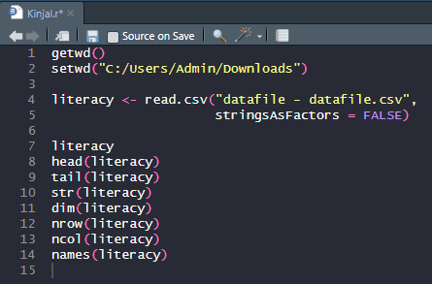

OUTPUT
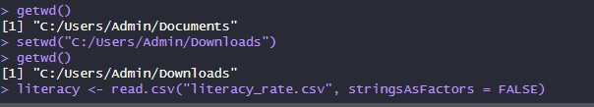

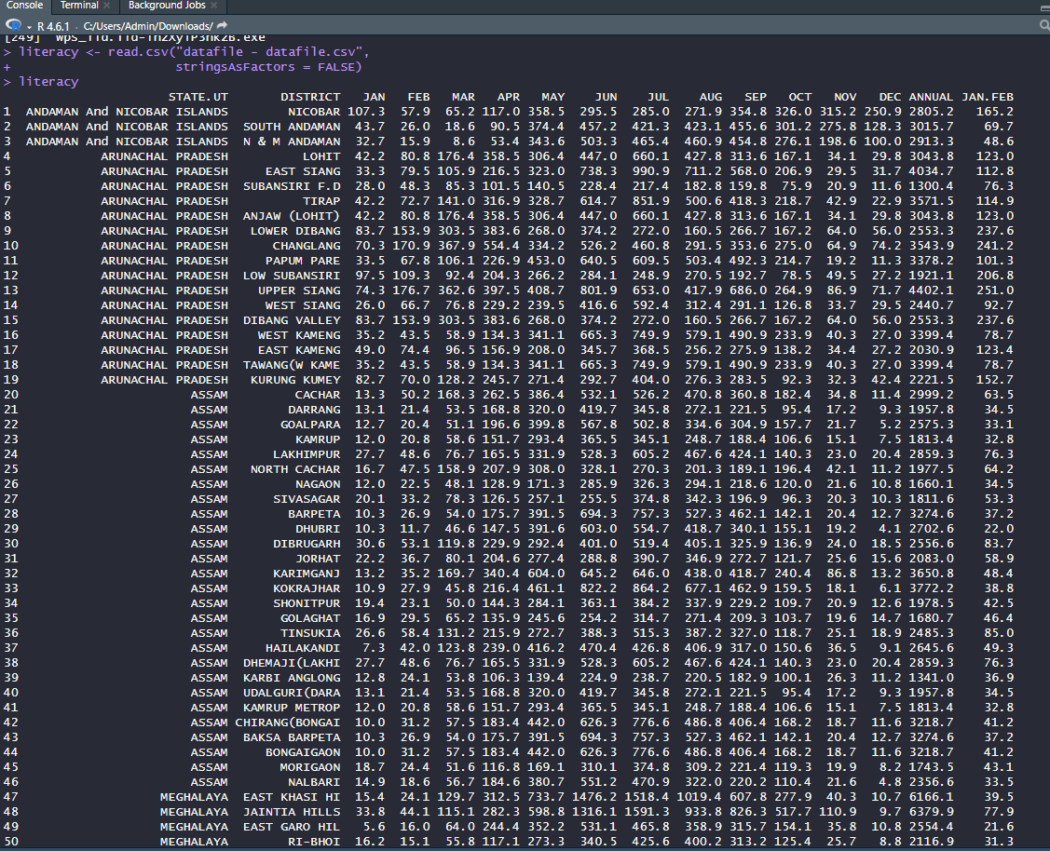

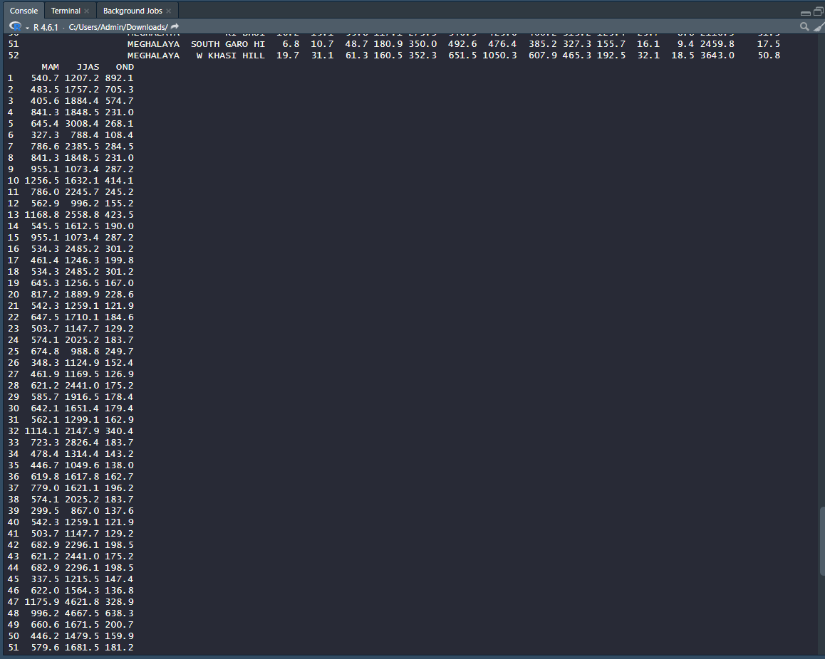

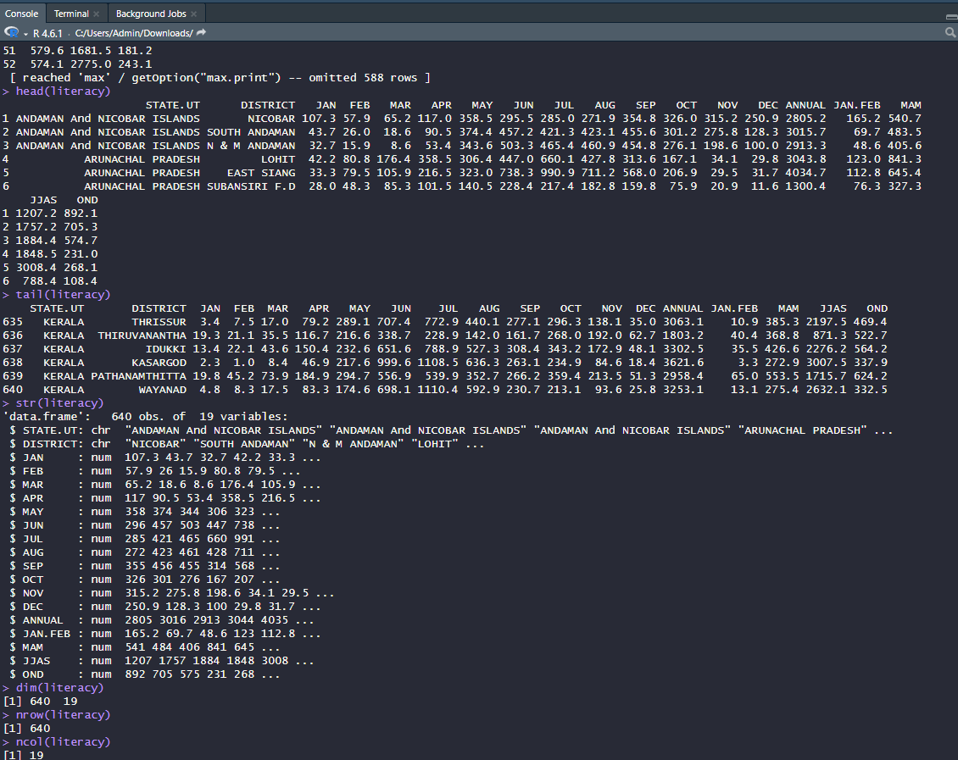

Result : The literacy dataset was successfully imported into R. The head() and tail() functions displayed the first and last six records, str() showed the dataset structure and data types, dim(), nrow(), and ncol() displayed the number of rows and columns, and names() listed all column names.

.

Conclusion: The experiment was completed successfully. The CSV file was imported into R, and the dataset was explored using basic R functions to view records, identify its structure, dimensions, and column names.

Questions of Curiosity

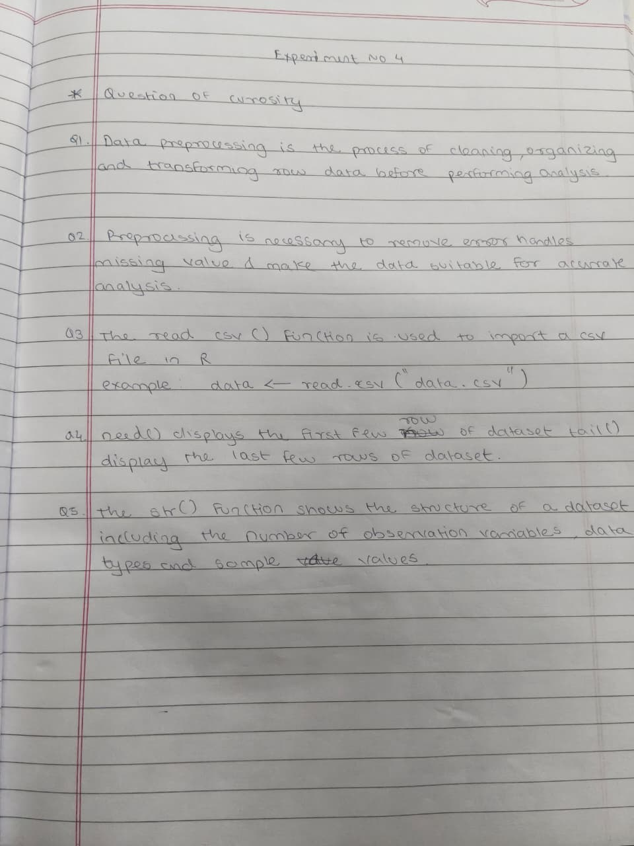

Viva Questions

- What is data preprocessing?
- Why is preprocessing necessary before data analysis?
- Which function is used to import a CSV file in R?
- What is the purpose of head() and tail()?
- What information does str() provide?
- How do you identify missing values in R?
- What is the use of na.omit()?
- How do you remove duplicate records?
- How can you rename a column in a data frame?
- How do you convert a character column into numeric?
- What is the difference between summary() and str()?
- Why should cleaned data be saved separately?
- What is the purpose of the subset() function?
- How do you sort a dataset in ascending and descending order?
- Name any four sources of Indian open datasets.

